η | Hotel & Studios  G. Sandalis
  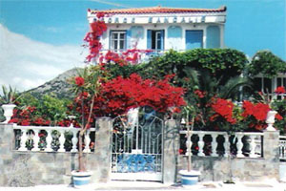
  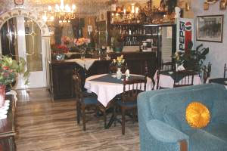
  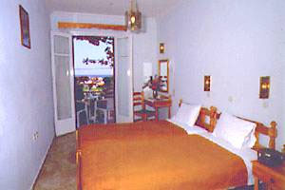

Hotel & Studios G. Sandalis is a classic 2 STAR Hotel. The hotel is located in the celebrated resort of Pytrhagorio right across the Pythagorio museum. It is only 1.5 miles from the airport, 300 meters away from the beach and 100 meters from the supermarket, cafes, bars and restaurants of the resort centre with its enchanting harbour and marina.
Pythagorion appeals to those who enjoy culture, scenery, cafe society and varied night life. If you wish to explore further a field, busses are available all day and taxis are available 24 hours. Alternatively you may hire a car and explore the island.
Hotel facilities and services include 20 hour reception & bar. All rooms have self catering kitchenettes with two electrical rings, ice box and fridge. There is also en-suite W.C – shower, telephone, TV, radio and safety deposit boxes.
Ten rooms have air-conditioning.
Air-conditioning is 24 hours a day. (Extra Charge)
Room facilities
The hotel has three floors. There are three rooms on the ground floor, three rooms on the first floor and six rooms on the second floor. This family run establishment offers twelve very tastefully decorated rooms, 9 with balconies with French doors and 3 with spacious terraces all of them being traditional Greek style accommodation. The nine rear rooms face the quiet hills and offer a panoramic view of the mountains and the sea while the three front rooms offer a view of our lovely flower garden. All rooms in the rear of the building are very relaxing, looking over towards the hills and the sea.
We promise you will be very satisfied and have a lovely vacation.
Hotel visitors have 15 % discount at our café-bar.
Our café bar “ENPLO” is located at the port of Pythagorio. We serve breakfast, coffees, drinks, ice creams, cocktails, sweets & a lot more.

HOTEL
G. SANDALIS
PYTHAGORIO
Samos Island
Zip code 83100
Greece
Phone: +30 2273061691
Fax: +30 2273061251
Mobile: +30 6938104377
E-mail:
sandalishotel@yahoo.gr

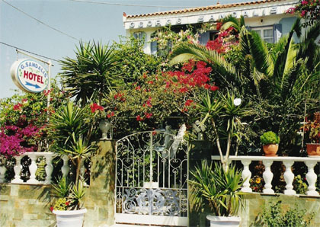

GEORGE SANDALIS HOTEL & STUDIOS 2007
Top of Form

Rates per Room
Room Type | Max.  Pers. |  | 01/04/2007 - 10/05/2007 | 11/05/2007 - 10/07/2007 | 11/07/2007- 31/08/2007 | 01/09/2007- 31/09/2007 | 01/10/2007- 31/10/2007
Studio | 2 |  | € 26.00 | € 28.00 | € 30.00 | € 28.00 | € 26.00

Optional Extras
Extra charge for reservations made for 1 or 2 days per room / day | € 2.00
Air Conditioning / day (24 hour service) | € 6.00

