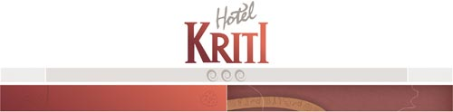
Nikiforou Foka & Kiprou, 73100, Hania, Crete - Greece
Tel.: +30 2821051881-3-5, Fax: +30 2821041000
E-mail: info@kriti-hotel.gr | URL: www.kriti-hotel.gr

OFFICIAL RATES 2005

SEASON A’: 01/01 – 30/04 & 01/11 - 31/12 EURO
BED & BREAKFAST
--------------------------------------------------------------------------------------------------------------
SINGLE 52,30
DOUBLE 65,40
TRIPLE 88,30
TRIPLE (Child 2-12 years old) 81,80
---------------------------------------------------------------------------------------------------------------

SEASON B’: 01/05 – 15/06 & 20/09 - 31/10
BED & BREAKFAST
---------------------------------------------------------------------------------------------------------------
SINGLE 57,50

DOUBLE 71,90
TRIPLE 97,10
TRIPLE (Child 2-12 years old) 89,90
---------------------------------------------------------------------------------------------------------------
SEASON C’: 16/06-19/09
BED & BREAKFAST
---------------------------------------------------------------------------------------------------------------
SINGLE 74,80
DOUBLE 93,50
TRIPLE 126,20
TRIPLE (Child 2-12 years old) 116,90
---------------------------------------------------------------------------------------------------------------

All the above rates are per room, per day including
Service charge and taxes
BABY COT FREE
CHILDREN (02- 12 years) 50% DISCOUNT
EXTRA BED 30% DISCOUNT
For breakfast the hotel provides Buffet style service
________________________________________________________________________
CH.V.I. GIANNOULIS S.A. KRITI HOTEL SANTA MARINA HOTEL SANTA MARINA BEACH HOTEL SANTA MARINA
HOTELS IN CRETE CHANIA CHANIA HERAKLION AG.NIKOLAOS

